YEAR 10 SCIENCE (GENERAL)
EXAMINATION REVISION - SEMESTER 2 2016

Natural and Processed Materials

1. The periodic table is useful for chemists as it arranges the elements in a particular way.

(a) What is a group?

(b) Why are elements put into a particular group?

(c) What are the group numbers of:

(i) alkali metals?

(ii) inert (noble) gases?

(iii) halogens?

(d) Where do you find the following elements in the table? Indicate them on the periodic table below, either
by labelling or colouring.

(i) transition elements
(ii) metalloids / semi-metals

(e) Where do you find the non-metal elements? Show this on the diagram below.

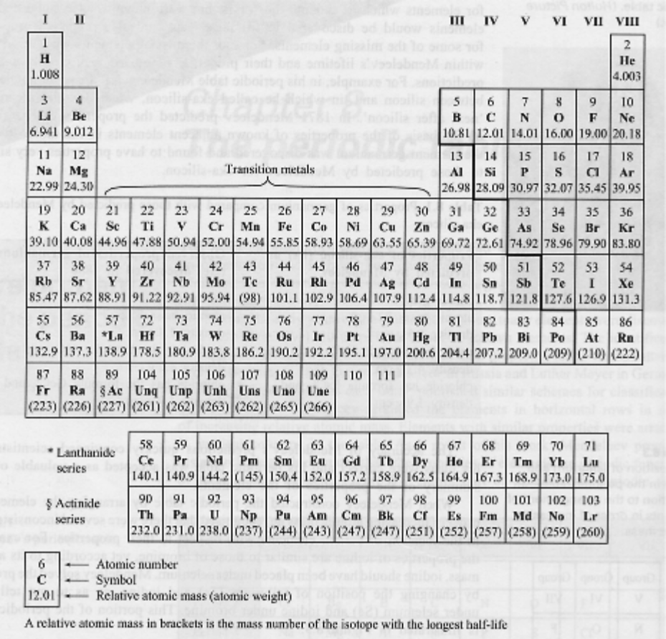

2. Give a definition or description for the following terms.

(a) element

(b) atomic number

(c) atomic mass

(d) ionic bond

(e) covalent bond

(f) valence electron

(g) Octet Rule

3. Complete the following table.

ELEMENT | PROTON NUMBER | NEUTRON NUMBER | ELECTRON NUMBER
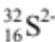
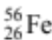
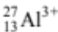

4. Draw clear diagrams to show the electron configurations of the following elements.

(a) 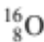 (b) 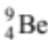

(c) 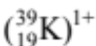 (d) 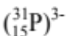

5. can form a 2- ion (O²⁻).

(a) Were electrons gained or lost to form the O²⁻ ion?

(b) How many electrons were gained or lost?

(c) In which group is O?

(d) What valency do all members of this group possess?

(e) Explain carefully why the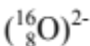 ion is stable, referring to the Octet Rule.
(HINT: Some mention of the noble or inert gases would be appropriate!)

6. Complete the table below by either writing a formula or name as required. Most are ionic compounds
and the rest are covalent molecules. For the ionic substances, show the ions used and your working.

COMPOUND | FORMULAE
iron (III) chloride
magnesium iodide
 | Fe(NO₃)₃
barium carbonate
ammonium sulphide
 | Al(OH)₃
lead (II) sulphate
potassium acetate
 | Zn₃(PO₄)₂
copper (ii) sulphate
sulphur trioxide
diphosphorus pentoxide
 | SF₆
nitrogen dioxide

7. Balance the following equations.

(a) MgO_{(s)} + HNO_{3(aq)}  Mg(NO₃)_{2(aq)} + H₂O_{(l)}

(b) Al_{(s)} + Cl_{2(g)}  AlCl_{3(s)}

(c) Ba(NO₃)_{2(aq)} + K₃PO_{4(aq)}  Ba₃(PO₄)_{2(s)} + KNO_{3(aq)}

(d) C₆H₁₂O_{6(s)} + O_{2(g)}  CO_{2(g)} + H₂O_{(g)}

(e) NH_{3(g)} + CuO_{(s)}  Cu_{(s)} + H₂O_{(l)} + N_{2(g)}

8. Write balanced equations using formulae for the following reactions.

(a) Aluminium metal + oxygen gas → solid aluminium oxide

(b) Potassium metal + oxygen gas → solid potassium oxide

(c) Copper (II) sulphate solution + sodium hydroxide solution → solid copper (II) hydroxide + sodium sulphate solution

(d) Solid magnesium hydroxide + hydrochloric acid → magnesium chloride + water

9. Predict whether a precipitate is produced when the following solutions are mixed together. For those that
produce a precipitate, write a balanced equation. Write "no reaction" if a precipitate is not produced.

(a) potassium sulphate solution + lead (II) nitrate solution

(b) zinc nitrate solution + sodium phosphate solution

(c) barium nitrate solution + sodium hydroxide solution

10. Describe four ways in which the rate of a reaction can be increased.

•

•

•

•

11. A conical flask contains 1.0 M HCl at 20 °C. A student adds 2.0 g of Mg metal to it and a reaction occurs, producing H₂ gas. Describe two ways in which the student could increase the rate of production of H₂ gas.

•

•

Physical Sciences

1. A man drives his car 800 m due East and then turns North, driving 300 m before stopping at a petrol station. It took him 120 s to get there.

(a) What distance he has driven.

(b) Calculate his average speed for the journey.

2. A balloon filled with hydrogen gas has a velocity of 40 m/s East. How long will it take to go 450 m ?

3. What is the average speed of a plane if it flies 2700 km in 2.3 hours? Give the answer in km/h.

4. A top sprinter reaches 11.2 m/s within 3.15 s of the start of a race. Calculate the average acceleration.

5. Calculate the final velocity of a car initially travelling at 10 m/s that accelerates at 1.4 m/s² for 10 s.

6. Determine the average acceleration of a car that increases its velocity from 7.0 m/s to 34 m/s in 9.0 s.

7. A truck moving at 36 m/s is decelerated uniformly at 1.5 m/s². What is its final velocity after 5.0 s?

8. A car of mass 1530 kg is travelling at 70.0 km/h along Hepburn Avenue when the driver has to brake sharply to
avoid a small child who suddenly appeared on a bike crossing the road.

(a) Convert the velocity of the car to m/s.

(b) If it took 3.5 s to stop the car, calculate the average force exerted by the brakes.

(c) The driver of the car was an engineer and had a hard-hat sitting on the back shelf. Describe what
happened to the hard-hat in this situation and explain why it took place.

9. (a) Explain the difference between mass and weight. Give an example to help your explanation.

(b) The acceleration due to gravity on Jupiter is 22.5 m/s². Calculate the weight of a 450 kg object on Jupiter.

10. A 70.0 kg cyclist is applying a force of 150 N forwards but is working against a wind producing a friction force
of 80 N opposing the movement.

(a) Determine the resultant force for this situation.

(b) Calculate the acceleration of the cyclist.

(c) It is possible for the rider to move at constant velocity. In terms of the forces acting, explain how this is
possible.

11 . You are sitting on a seat at the moment. Explain why you don't fall through the chair and are supported by it.

